Human Impact on Dolphins and the Ocean
ENVS 100W -- Section 1
Environmental Research and Writing
by
Snigdha Gurram
May 12, 2022

INTRODUCTION
The future is near, but so far away. Has anyone ever thought about what the ocean would look like in the future? Well in a little less than 30 years, around 2050, the ocean will be filled with more plastic than fish (Foresight 2019). Although it is not just fish in the ocean, many other marine lives can be affected. One of them being dolphins. Dolphins and humans are similar in a few ways. A study was done between dolphins, chimpanzees, and humans. Both chimpanzees and dolphins were tested with matching tests and humans were tested with a rating test which concluded that they are all similar mammals (Tomonaga 2014). This was interesting to find out because it is known that humans evolve from chimpanzees. Another study was done that showed that dolphins have personalities and DNA that are extremely like humans (McGowen 2012). Humans being like dolphins is like humans harming humans. Humans have had a large impact on the ocean and marine life. Many of the injuries to dolphins have happened because of fishing methods and other industrial plants that dispose of their waste into the ocean. The fishing nets that are set not only have a possibility of injuring the dolphins and other ocean animals but also damaging the nets for fishing which in turn affects the fishers who need to buy new nets (Snape 2018). There is another method that humans use to hunt which is dive hunting. Dive hunting is similar to whaling but instead towards dolphins. This leads to the hunting of dolphins for meat that is sold to countries that want it as food or medicinal value (Palmer 2019). Pollution is the major cause of problems for dolphins and marine life. There are different pollution factors that humans cause to create a negative impact. The different types are plastic, noise chemical, light, and heat. The focus will be on plastic and chemical pollution. Pollution created by humans, especially plastic pollution, has harmed dolphins. The components that come into play are the amounts of pollution that countries contribute to around the world, the effects that pollution plastic and chemicals can have on dolphins, and ways to prevent the dumping through cleanup events and nonprofit organizations.
Humans’ Impact on the Ocean
The ocean is such a large part of the Earth, but just because it is large does not mean humans will not have an impact on it in some way. About 71% of the Earth’s surface is covered in water. 96.5 % is saltwater, while the remaining 2.5% is freshwater (Water Science School 2019). Freshwater can be found in different places like glaciers and rivers. Humans can only use the freshwater for their daily uses like drinking, toilets, sinks, baths, food production, power generation, manufacturing, and sanitation (Ros n.d.). Without water, humans and many other life forms would probably not survive. On average, humans use about 101.5 gallons of water per day (Philadelphia Water Department n.d.). After understanding this, imagine the amount of water that could be saved to be used later because of the limited amount that humans must use. Although this is one of the factors, it is not the only one that needs to be saved. Humans produce a significant amount of garbage on a global scale through the many things that are used like food containers, containers to carry products or items that have gotten too old to use any longer. In the world, humans produce almost 3.5 million tons of solid waste in a single day (Leahy 2018). Over the many years of talking about plastic pollution in the ocean, some people have started to understand that the way of life needs to be changed. People have been trying to be more understanding towards their impacts by being sustainable, reusing, reducing, and recycling whatever can be.
Global Ocean Dumping
There is a certain place that many people go to that could use a lot of clean-up; this is the beach. Beaches are a popular place for people to visit, especially during summer vacation. Which can lead to too many people being there at once. This leads to an excess of trash that is left on the beach that either gets blown by the wind into the ocean or the tide pulls it into the water. The different types of trash that can end up on beaches, of the top ten most to least things, are cigarette butts, food wrappers, plastic bottles, plastic bottle caps, plastic grocery bags, other plastic bags, straws, stirrers, plastic take out containers, plastic lids, and foam takes out containers (EcoWatch 2018). In figure 1, it shows the percentages of plastic in the ocean and how much of the marine life it has affected.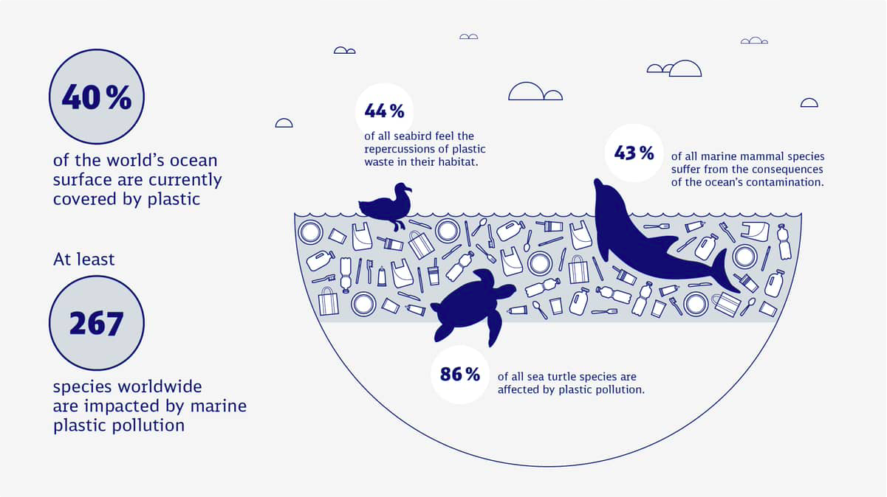
Figure 1. Amount of plastic in the ocean and effects on marine life.
Source: Data from DB Schenker, 2020, figure 1
Plastic has been a problem that people have known about from turtles and straws to coral bleaching, but there have not been many positive results to change this. While plastic pollution is a serious problem, it can also have beautiful results because of what is Mother Nature. An example of what could happen if plastic erodes in a way to have a positive impact rather than a negative is glass beach. Glass beach is a beach in Fort Bragg, California where the beach is covered in colorful smoothened glass pieces instead of sand. This is a great example of how it can be positive but at the same time, it shows the amount of waste that ends up in the ocean. Plastic on the other hand has, for the most part, caused harm to dolphins and all marine animals. Sometimes the animals that get impacted is not even the one that lives in the ocean. In the ocean, there is pollution and figure 2 it shows the amount of pollution that major countries contribute to the plastic in the ocean.
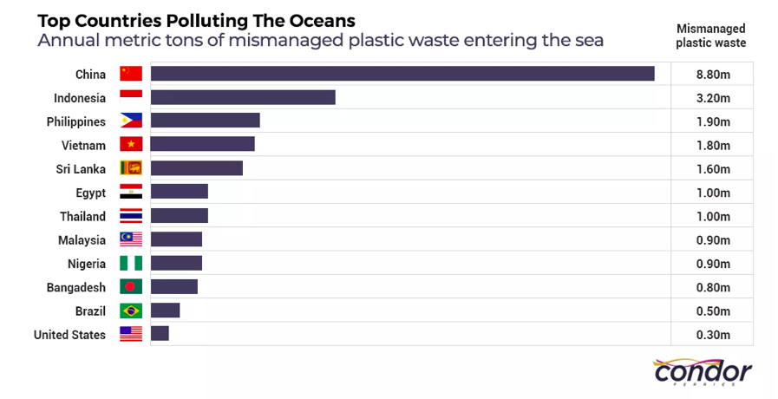
Figure 2. Plastic pollution that majors countries contribute to the pollution in the ocean in metric tons.
Source: Data from CondorFerries 2022, figure 1
Plastic has had a serious impact on marine life by causing negative impacts to a million seabirds and 100,000 marine animals each year which have caused death because of the plastic pollution throughout the world (CondorFerries 2022). Plastic can cause death to marine animals because of the long plastic pieces strangling them or suffocating them over time or right away. There is a significant amount of plastic that ends up in the ocean, which accumulates to about 5.25 trillion macro and microplastic that are in the oceans all over the world because of human trash ending up in the ocean (CondorFerries 2022). The trash is easy to pick up, but people never seem to do it. So, the continued cycle of plastic ending up in the ocean goes on.

Pollution Effects on Dolphins

Plastic Pollution Effects on Dolphins
If all the plastic in the ocean was collected it can be reused to make clothing, water bottles, and more. Many pollution factors can have an impact on the planet. These factors can be light, sound, heat, chemicals, garbage, and more. The main pollution factors that would impact dolphins are chemicals and plastic. Dolphins can and will be affected by plastic because it is the most common pollutant in the ocean, so it is everywhere whether it can be seen or not. Figure 3, it shows the plastic waste in England and what items cause the pollution, how much plastic is dumped into the ocean, and its effects on the animals in the ocean.
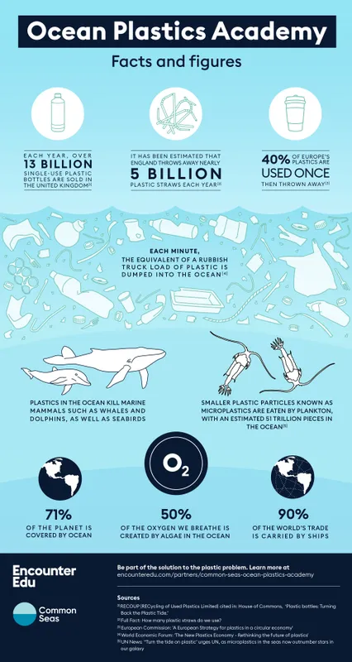
Figure 3. Different plastics used in the United Kingdom and the ocean animals they affect.
Source: Data from Encounter Edu n.d., figure 1
The part of this figure that stood out was that plastic kills large marine mammals while microplastic affects the large mammals and the small animals like plankton. The items of plastic that are found within the ocean can be plastic bags, straws, or bottle caps. All these plastic items can look like food to the ocean animals. For example, this is a plastic bag that can look like a jellyfish to turtles. Other things that can happen are plastic straws stuck in turtle noses and plastic can holding cases stuck around their necks (Gregory 2009). The plastics that humans regularly see turn into microscopic pieces called microplastics, which are the most common plastic that gets consumed by animals. The microplastics are swallowed unknowingly because of how small they are and are just taken in as the dolphins, and other marine animals, try to eat their actual food. As time goes on the microplastic build-up leads to serious harm or even death. The death occurs because of the microplastic making the dolphins feel as though they have already eaten, so they no longer feel hungry which leads to starvation. In one recent study, there were plastic fiber strands that were found in the stomachs of already deceased dolphins (Novillo 2020). Plastic is the pollutant that is talked about more than others but another pollutant that has a large impact is chemicals.
Chemical Pollution Effects on Dolphins
Plastic is not the only polluter that has a large impact on the dolphins. Chemicals have been also detected in the ocean. These chemicals end up into the ocean from the trash that is dumped or from factories and industries releasing their waste into the ocean. Some examples of items that are found of beaches are plastic toys, farms, industries, medicines, and even from homes (Sea Pollution 2014). While the chemical waste from factories gets released into the oceans because through the water that is used to cool down the machines (Huang 2019). These chemicals, as helpful as they would be, are not visible to the naked eye since they get mixed into the ocean’s salty waters. Just because the chemicals cannot be seen does not mean their impact is any less to the marine life. The chemicals make their way into the ocean from farm and other areas that use pesticides. Figure 4 represents the amounts of different chemicals that get released into the Earth’s water.
Figure 4. The amounts of different chemicals that get released into bodies of water in large amounts.
Source: Data from EPA 2021, figure 1
In another study, two bottlenose dolphins were looked at and found to have high levels of chemicals like cadmium, lead, iron, and selenium which can only be found when they are repeatedly in contact with them (Page-Karjin 2020). These high levels of chemicals are not only harmful to the marine life, but also can have negative impacts to humans if they do come in contact for long periods of time. As the dolphins thrive in the ocean for their entire lives, the effects of the chemicals have a great effect. An example, organochlorine pesticides which have been banned in the EU, have caused a decrease in the population of the mammals that are the highest on the food chain. This shows how dangerous the simple pesticides can be if they are in the wrong places (Jepson 2016). To prevent this, people need to be more aware of what they are doing and what is in the products that are being used.
Methods for People to Help Dolphins from Pollution
Plastic and chemicals in the ocean can harm dolphins and other marine life, but these are not the only ways that can cause detrimental damages. Vessels in the ocean like ships, boats, and cruises can also threaten marine life. In a study, the authors wrote some recommendations about was to management the vessels. Something that can be noticed is that these recommendations can also be implemented on other forms of harm like plastic and chemical pollution. The study provides five recommendation which are to “increase enforcement of guidelines and regulations, revisit viewing distance and vessel speed guidelines, increase education and awareness, redesign management systems, and implement time-area closures or marine protected areas” (Puszka 2021). These are just a few ways to lessen the impact on the ocean and the dolphins.
By enforcing the guidelines and regulations it can help to hold people accountable for their mistakes. These mistakes can consist of going into restricted areas to make profit through selling meat of mammals that countries may want. A great way for the government to do this is to put out policies and laws to strongly encourage the communities to stray away from the negative repercussions that can occur.
Enforcing the speed and distance of vessels can help reduce the causalities of vessels colliding with marine mammal that come up to the ocean surface out of curiosity or to breath. The collisions can affect about 75 marine species, with most of the collisions being between large mammals (Schoeman 2020). To do this there can be speed limits and speed meters added to areas that vessels go on so that people can pay attention to their speed.
Educating and being awareness is the method that anyone can do because of the internet and social media. There are already many other ways to spread awareness of the ocean and the life that is affected. Some ways can be to educate students in school as a part of biology and environmental science instead of the subject only being about the science behind it. Educating people from a young age is the best way to retain the information as well as reintroduce it over the course of children’s education.
Changing the management would help to reinforce and implement new safety measures for marine life and humans so that both sides are always safe. By changing the management there can be new idea that are effective towards the current generation and their way of life. Management changes are happening in other governmental positions like presidents and majors. This is because of the perspectives that people can bring due to their knowledge based on how the community is now to make effective changes.
Closing areas at certain time and marine protected areas can help preserve and protect the marine life from the dangers on human activity. The protected areas would be areas that consist of mating and endangered areas so that there can be a less impact on that ecosystem. Closing areas that are not used as much would prevent people from exposing that habitat to the public, so that they can be safe.
CONCLUSION
The Problems of Pollution
If the plastic pollution continues to occur this can lead to many problems that can make things worse. One of the problems is that by 2050 the ocean will end up having more plastic in the ocean and less fish (Foresight 2019). There is already a loss in fish because of the amount of fishing type people use that harm their environment because also affect the mammals that survive on them. Not only that but there are certain countries that pollute most of the plastic is found in the ocean. Most of the plastic that is in the ocean mainly comes from five countries. These five countries are China, Indonesia, Philippines, Thailand, and Vietnam (EcoWatch 2015). The reason for the ocean pollution problems is because there are no regulations to prevent people from dumping. This is an obstacle that has occurred for many of the other problems in the world and they are all because of improper regulations or lack thereof. The planet has around 40% of the ocean that is not regulated (Foresight 2019), many of the problem to come from this. This is because without regulation anyone from any countries can do whatever they like without repercussions. Some of the problems are pollution, illegal hunts and harvesting of marine life like dolphins.

Future Studies
To prevent the pollution and harm to dolphins, the ocean, and the rest of the life in the ocean studies must be done to understand what needs to be corrected. A way that has been talked about is to track the amount of microplastics there are in the ocean over the years. This can be traced through the weight of the microplastic that is found. Each study from the past years can be compared to understand if the amount of plastic grows or reduces (Hale 2020). By tracking this, scientists can calculate the changes that occur to understand the changes that should be made. A way to notice chemicals are in the ocean is by taking a sample of the ocean water and adding a nontoxic indicator into the water to visibly see an imbalance if there is one. Making indicators for plastics and chemicals in the ocean can be an easier way to detect them (Galgani 2015). Not only the chemicals but also the plastic has to be indicated so that there can be a visible notification of where the pollutants are coming from. There needs to be more knowledge of the plastics in the oceans so that there can be studies on how to detect them since the plastics and chemical are not visible to anyone (Galgani 2015). These chemicals and plastics are extremely unnoticeable to any eye, so having a way to detect them would help towards the health of the ocean and the life in it. Another study that should be conducted is to watch over how dolphins are doing in the ocean. This can be done by checking in deceased dolphins’ stomachs to understand the amount of microplastics that appear (Novillo 2020). This way there can be more action to reduce the amount of microplastics in the stomachs of dolphins that are alive (Novillo 2020). This action can be taken by adding trackers to dolphins so that the scientist can check up on the dolphins occasionally to study if the reduction of plastic and chemicals is working or not.

TABLES AND FIGURES
CondorFerries. 2022. “100+ Ocean Pollution Statistics & Facts (2020-2021).” Condor Ferries, https://www.condorferries.co.uk/marine-ocean-pollution-statistics-facts.

EPA. 2021. “Water Releases by Chemical & Industry.” EPA, Environmental Protection Agency, https://www.epa.gov/trinationalanalysis/water-releases-chemical-industry.

Encounter Edu. n.d. “How Much Plastic Is in the Ocean?” Encounter Edu, https://encounteredu.com/multimedia/images/ocean-plastics-facts-and-figures.

“The Clock Is Ticking: Plastic Pollution in the Ocean,” 2020. DB Schenker, https://www.dbschenker.com/global/about/press/global-stories/exxpedition.
REFERENCES
CondorFerries. 2022. “Shocking Ocean Plastic Statistics: The Threat to Marine life, The Ocean & Humanity,” CondorFerries, https://www.condorferries.co.uk/plastic-in-the-ocean-statistics.

CondorFerries. 2022. “100+ Ocean Pollution Statistics & Facts (2020-2021).” Condor Ferries, https://www.condorferries.co.uk/marine-ocean-pollution-statistics-facts.

EcoWatch.com. 2015. “These 5 Countries Account for 60% of Plastic Pollution in Oceans,” Waste 360, https://www.waste360.com/plastics/these-5-countries-account-60-plastic-pollution-oceans

EcoWatch. 2018. “10 Most Common Types of Beach Litter Are All Plastic,” Ocean Conservacy, https://www.ecowatch.com/beach-litter-plastics-ocean-conservancy-2581760475.html

EPA. 2021. “Water Releases by Chemical & Industry.” EPA, Environmental Protection Agency, https://www.epa.gov/trinationalanalysis/water-releases-chemical-industry.

Foresights. 2019. “Plastic Oceans,” Future Agenda, https://www.futureagenda.org/foresights/plastic-oceans/

Galgani, François. 2015. “Marine Litter, Future Prospects for Research,” Frontiers in Marine Science, 2, no. October: 1–5. https://doi.org/10.3389/fmars.2015.00087.

Gregory, Murray R. 2009. “Environmental Implications of Plastic Debris in Marine Settings—Entanglement, Ingestion, Smothering, Hangers-on, Hitch-Hiking and Alien Invasions,” Philosophical Transactions of the Royal Society B 364, 364, no. 1526: 2013–25. https://doi.org/10.1098/rstb.2008.0265.

Hale, Robert C, Meredith E Seeley, Mark J La Guardia, Lei Mai, and Eddy Y Zeng. 2019. “A Global Perspective on Microplastics.” Journal of Geophysical Research: Oceans, 125. https://agupubs.onlinelibrary.wiley.com/doi/full/10.1029/2018JC014719.

Huang, Faming, Jie Lin, and Binxin Zheng. 2019. “Effects of Thermal Discharge from Coastal Nuclear Power Plants and Thermal Power Plants on the Thermocline Characteristics in Sea Areas with Different Tidal Dynamics,” Water (Basel) 11, no. 12: 2577. https://doi.org/10.3390/w11122577.

Jepson, Paul D, Rob Deaville, Jonathan L Barber, Àlex Aguilar, Asunción Borrell, Sinéad Murphy, Jon Barry, et al. 2016. “PCB Pollution Continues to Impact Populations of Orcas and Other Dolphins in European Waters.” Scientific Reports 6. Springer Science and Business Media LLC. https://doi.org/10.1038/srep18573.

Leahy, Stephen. 2018. “How People Make Only a Jar of Trash a Year,” National Geographic, https://www.nationalgeographic.com/science/article/zero-waste-families-plastic-culture

McGowen, Michael R, Lawrence I Grossman, and Derek E Wildman. 2012. “Dolphin Genome Provides Evidence for Adaptive Evolution of Nervous System Genes and a Molecular Rate Slowdown,” Proceedings of the Royal Society. B, Biological sciences, 279, no. 1743: 3643–51. https://doi.org/10.1098/rspb.2012.0869.

Novillo, O, J.A Raga, and J Tomás. 2020. “Evaluating the Presence of Microplastics in Striped Dolphins (Stenella Coeruleoalba) Stranded in the Western Mediterranean Sea,” Marine pollution bulletin 160, no. November: 111557. https://doi.org/10.1016/j.marpolbul.2020.111557.

Page-Karjian, Annie, Catherine F Lo, Branson Ritchie, Craig A Harms, David S Rotstein, Sushan Han, Sayed M Hassan, et al. 2020. “Anthropogenic Contaminants and Histopathological Findings in Stranded Cetaceans in the Southeastern United States, 2012–2018,” Frontiers in Marine Science, 7, no. August. https://doi.org/10.3389/fmars.2020.00630.

Puszka, Helena, Jeff Shimeta, and Kate Robb. 2021. “Assessment on the Effectiveness of Vessel- Approach Regulations to Protect Cetaceans in Australia: A Review on Behavioral Impacts with Case Study on the Threatened Burrunan Dolphin (Tursiops Australis).” PLoS ONE, 16, no. 1https://journals.plos.org/plosone/article?id=10.1371/journal.pone.0243353.

Republic, Studio. “These 10 Countries Are the Biggest Contributors to Marine Plastic Pollution – New Analysis.” CIWEM, https://www.ciwem.org/news/10-countries-biggest-contributors-marine-plastic-pollution.

Ros, Jason P. n.d. “Freshwater,” National Geographic, https://www.nationalgeographic.org/education/freshwater/

Schoeman, Renée P., Claire Patterson-Abrolat, and Stephanie Plön. 2020. “A Global Review of Vessel Collisions With Marine Animals,” Frontiers in Marine Science, 7, no. May. https://doi.org/10.3389/fmars.2020.00292.

“Sea Pollution,” 2014., Young People’s Trust For the Environment, https://ypte.org.uk/factsheets/sea-pollution/chemical-pollution.

Tomonaga, Masaki, Yuka Uwano, and Toyoshi Saito. 2014. “How Dolphins See the World: A Comparison with Chimpanzees and Humans,” Scientific reports, 4, no. 1: 3717. https://doi.org/10.1038/srep03717.

Water Science School. 2019. “How Much Water is There on Earth?,” USGS, https://www.usgs.gov/special-topics/water-science-school/science/how-much-water-there-earth.

